Our project is named as ‘ID_RecognitionSystem’.

Open our project in MatLab as shown in the following figure.

In command window, input “addpath('CIDRS'),id_rec_gui” and press ‘Enter’.

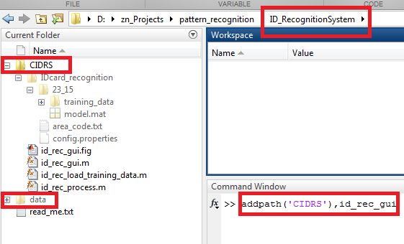

When open this window, click ’Select Samples’ to select original images.

Click ‘Save Result’ to save segmentation images (training data).

Click ‘Train Model’ to train our model

Click ‘validate’ to do recognition

